|  |  |  |  |
| --- | --- | --- | --- |
|  | **Course Name: Advanced Web Technology** | **EXPERIMENT NO. 2** | |
| **Course Code: 20CP314P**  **Faculty: Komal Singh** | **Branch: CSE** | **Semester: VI** |
| **(To be filled by Student)**  **Submitted by: Puja Mavadhiya**  **Roll no: 21BCP446D** | | | |

Objective: Building a Web Server with Express.js

Experiment 2: Implement with routing methods (GET and POST) and also implement one built-in middleware, configurable middleware and one third party middleware (Cookie-Parser).

Hint: You can also use the function validate cookie in third party middleware.

Note: Please include snapshots of all commands, terminal sessions, localhost outputs, and log files in your documentation.

Configure middleware:

const express = require('express');

const app = express();

const port = 3000;

app.use(function(req, res, next){

  console.log("start");

  next();

});

app.get('/',function(req,res,next){

  res.send("Middle")

  next();

});

app.use('/', function(req,res){

  console.log('End');

});

app.listen(port, () => {

  console.log(`Server is running at http://localhost:${port}`);

});

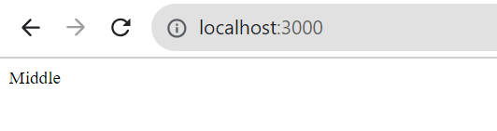

Routing methods:

Form.html:

<html>

    <head>

    </head>

    <body>

        <form action="/submit" method="post">

            <label for="name">Name:</label>

            <input type="text" id="name" name="name" required></br></br>

            <label for="rollNo">Roll Number:</label>

            <input type="text" id="rollNo" name="rollNo" required>

        </br></br>

            <button type="submit">Submit</button>

        </form>

    </body>

</html>

Index.js:

const express = require('express');

const bodyParser = require('body-parser');

const app = express();

const port = 3000;

app.use(bodyParser.urlencoded({ extended: true }));

app.get('/', (req, res) => {

    res.sendFile(__dirname + '/form.html');

});

app.post('/submit', (req, res) => {

    const name = req.body.name;

    const rollNo = req.body.rollNo;

    console.log('Name:', name);

    console.log('Roll Number:', rollNo);

    res.send('Hello'+name+ 'Roll no '+rollNo+'form submitted sucessfully');

});

app.listen(port, () => {

    console.log(`Server is running on http://localhost:${port}`);

});

